WAILDD
Paired Samples Statistics
 |  | Mean | N | Std. Deviation | Std. Error Mean
Pair 1 | PRE TEST | 9.80 | 15 | 1.265 | 0.327
 | POST TEST | 3.87 | 15 | 0.990 | 0.256

Paired Samples Test
 |  | Paired Differences |  |  |  |  | t | df
 |  | Mean | Std. Deviation | Std. Error Mean | 95% Confidence Interval of the Difference |  |  |  | Two-Sided p
 |  |  |  |  | Lower | Upper
Pair 1 | PRE TEST - POST TEST | 5.933 | 0.594 | 0.153 | 5.605 | 6.262 | 38.711 | 14 | 0.000

Paired Samples Statistics
 |  | Mean | N | Std. Deviation | Std. Error Mean
Pair 1 | PRE TEST | 9.67 | 15 | 1.234 | 0.319
 | POST TEST | 6.93 | 15 | 0.961 | 0.248

Paired Samples Test
 |  | Paired Differences |  |  |  |  | t | df
 |  | Mean | Std. Deviation | Std. Error Mean | 95% Confidence Interval of the Difference |  |  |  | Two-Sided p
 |  |  |  |  | Lower | Upper
Pair 1 | PRE TEST - POST TEST | 2.733 | 0.458 | 0.118 | 2.480 | 2.987 | 23.127 | 14 | 0.000

Group Statistics
sample |  | N | Mean | Std. Deviation | Std. Error Mean
PRE TEST | group 1 | 15 | 9.80 | 1.265 | 0.327
 | group 2 | 15 | 9.67 | 1.234 | 0.319

Independent Samples Test
 |  | t-test for Equality of Means
 |  | t | df |  | Mean Difference | Std. Error Difference | 95% Confidence Interval of the Difference
 |  |  |  | Two-Sided p |  |  | Lower | Upper
PRE TEST | Equal variances assumed | 0.292 | 28 | 0.772 | 0.133 | 0.456 | -0.801 | 1.068
 | Equal variances not assumed | 0.292 | 27.983 | 0.772 | 0.133 | 0.456 | -0.801 | 1.068

Homogeneity of Variance Test
 |  | Levene's Test for Equality of Variances
 |  | F | Sig.
PRE TEST | Equal variances assumed | 0.006 | 0.941

Group Statistics
sample |  | N | Mean | Std. Deviation | Std. Error Mean
POST TEST | group 1 | 15 | 3.87 | 0.990 | 0.256
 | group 2 | 15 | 6.93 | 0.961 | 0.248

Independent Samples Test
 |  | t-test for Equality of Means
 |  | t | df |  | Mean Difference | Std. Error Difference | 95% Confidence Interval of the Difference
 |  |  |  | Two-Sided p |  |  | Lower | Upper
POST TEST | Equal variances assumed | -8.606 | 28 | 0.000 | -3.067 | 0.356 | -3.797 | -2.337
 | Equal variances not assumed | -8.606 | 27.975 | 0.000 | -3.067 | 0.356 | -3.797 | -2.337

Homogeneity of Variance Test
 |  | Levene's Test for Equality of Variances
 |  | F | Sig.
POST TEST | Equal variances assumed | 0.096 | 0.759

MOOS
Paired Samples Statistics
 |  | Mean | N | Std. Deviation | Std. Error Mean
Pair 1 | PRE TEST | 66.33 | 15 | 6.466 | 1.670
 | POST TEST | 47.93 | 15 | 4.605 | 1.189

Paired Samples Test
 |  | Paired Differences |  |  |  |  | t | df
 |  | Mean | Std. Deviation | Std. Error Mean | 95% Confidence Interval of the Difference |  |  |  | Two-Sided p
 |  |  |  |  | Lower | Upper
Pair 1 | PRE TEST - POST TEST | 18.400 | 5.110 | 1.319 | 15.570 | 21.230 | 13.945 | 14 | 0.000

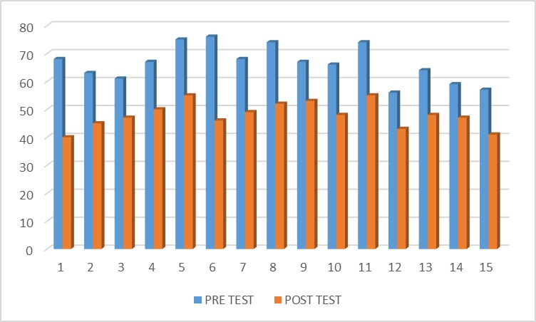

Paired Samples Statistics
 |  | Mean | N | Std. Deviation | Std. Error Mean
Pair 1 | PRE TEST | 62.20 | 15 | 5.809 | 1.500
 | POST TEST | 50.67 | 15 | 6.894 | 1.780

Paired Samples Test
 |  | Paired Differences |  |  |  |  | t | df
 |  | Mean | Std. Deviation | Std. Error Mean | 95% Confidence Interval of the Difference |  |  |  | Two-Sided p
 |  |  |  |  | Lower | Upper
Pair 1 | PRE TEST - POST TEST | 11.533 | 3.420 | 0.883 | 9.639 | 13.427 | 13.062 | 14 | 0.000

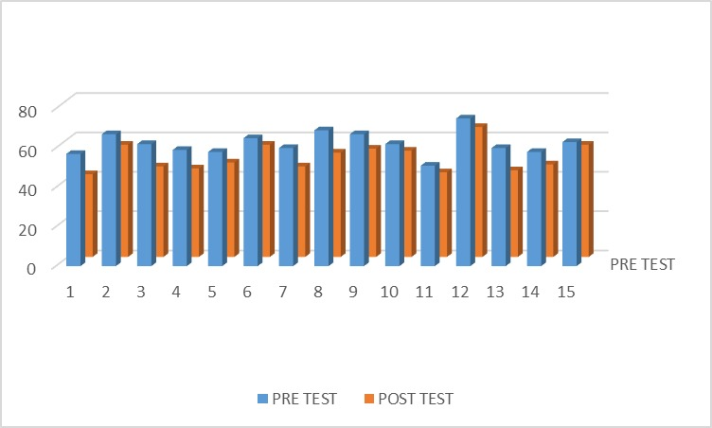

Group Statistics
sample |  | N | Mean | Std. Deviation | Std. Error Mean
PRE TEST | group 1 | 15 | 66.33 | 6.466 | 1.670
 | group 2 | 15 | 62.20 | 5.809 | 1.500

Independent Samples Test
 |  | t-test for Equality of Means
 |  | t | df |  | Mean Difference | Std. Error Difference | 95% Confidence Interval of the Difference
 |  |  |  | Two-Sided p |  |  | Lower | Upper
PRE TEST | Equal variances assumed | 1.842 | 28 | 0.076 | 4.133 | 2.244 | -0.464 | 8.731
 | Equal variances not assumed | 1.842 | 27.684 | 0.076 | 4.133 | 2.244 | -0.466 | 8.733

Homogeneity of Variance Test
 |  | Levene's Test for Equality of Variances
 |  | F | Sig.
PRE TEST | Equal variances assumed | 0.302 | 0.587

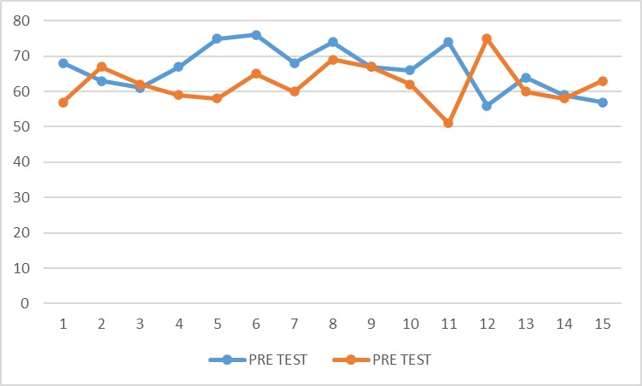
Group Statistics
sample |  | N | Mean | Std. Deviation | Std. Error Mean
POST TEST | group 1 | 15 | 3.87 | 0.990 | 0.256
 | group 2 | 15 | 6.93 | 0.961 | 0.248

Independent Samples Test
 |  | t-test for Equality of Means
 |  | t | df |  | Mean Difference | Std. Error Difference | 95% Confidence Interval of the Difference
 |  |  |  | Two-Sided p |  |  | Lower | Upper
POST TEST | Equal variances assumed | -8.606 | 28 | 0.000 | -3.067 | 0.356 | -3.797 | -2.337
 | Equal variances not assumed | -8.606 | 27.975 | 0.000 | -3.067 | 0.356 | -3.797 | -2.337

Homogeneity of Variance Test
 |  | Levene's Test for Equality of Variances
 |  | F | Sig.
POST TEST | Equal variances assumed | 0.096 | 0.759

